39.33: Following the hint:
If we Taylor expand sin() about a point 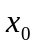, we get 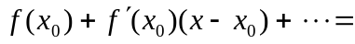
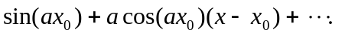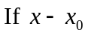 is small we can even ignore the first order term and sin() sin (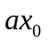).
For us 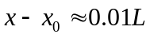 which is small compared to 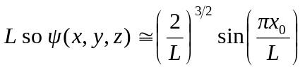
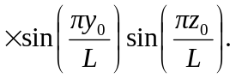
a) 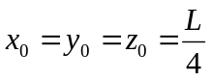
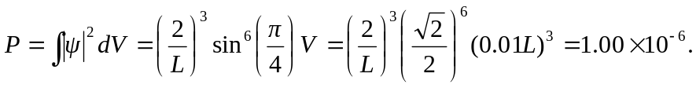
b) 